
Protocol 010: INOC 22-26

AHDB Recommended Lists (RL) for cereals and oilseeds: Inoculated disease trials (2021–26)
(Version 2026.1, October 2026)

This protocol was believed to comply with relevant agrochemical, environmental and other regulations at the time of writing but it is the responsibility of the contractor to ensure that it continues to comply. In the event of non-compliance the protocol should not be followed but the Field Trials Manager should be notified at once of how the protocol requirements would breach regulations.

Any deviation from this protocol other than under the circumstances described above may result in a breach of contract and should be agreed in advance.

While the Agriculture and Horticulture Development Board seeks to ensure that the information contained within this document is accurate at the time of printing, no warranty is given in respect thereof and, to the maximum extent permitted by law, the Agriculture and Horticulture Development Board accepts no liability for loss, damage or injury howsoever caused (including that caused by negligence) or suffered directly or indirectly in relation to information and opinions contained in or omitted from this document.

Reference herein to trade names and proprietary products without stating that they are protected does not imply that they may be regarded as unprotected and thus free for general use. No endorsement of named products is intended, nor is any criticism implied of other alternative, but unnamed, products.

AHDB Cereals & Oilseeds is a part of the Agriculture and Horticulture Development Board (AHDB).

Changes from previous version
Table 1 – summary of changes relative to previous version of this document
Page no. | Section | Details of change
Various | Various | References to ‘Disease Test Coordinator’ & ‘Pathology Trials Coordinator’ changed to RL Disease Lead
11 | 6.4 | Removed statement saying only disease assessments with average 20% infection can be used in ratings.
18 | 14 | Removed statement on additional recording columns being supplied in a separate file and then being pasted into relevant data sheet.
18 | 14.1 | Updated statement on how plan changes should be clearly recorded in workbooks

Contents
Each of the sections listed below can be used to navigate the document by left clicking the relevant section whilst pressing the Ctrl button at the same time.

TITLE PAGE 1
Changes from previous version 2
Part 1: Scope 5
Part 2: General introduction 5
2.1 Seed supply for tests 5
2.1.1 Seed supply for spreaders and controls 5
2.2 The trial sites 5
2.3 Method modifications 6
2.4 Disease assessment schedule 6
Part 3: Yellow Rust of Wheat 8
3.1 Location of tests* 8
3.2 Source of inoculum 8
3.3 Multiplication of inoculum 8
3.4 Varieties in test 8
3.5 Number of tests each year 8
3.6 Method 8
Part 4: Brown Rust of Wheat 9
4.1 Location of tests* 9
4.2 Source of inoculum 9
4.3 Multiplication of inoculum 9
4.4 Varieties in test 9
4.5 Number of tests each year 9
4.6 Method 9
Part 5: Eyespot of wheat 10
5.1 Location of tests* 10
5.2 Collection, storage and multiplication of inoculum 10
5.3 Varieties in test 10
5.4 Method 10
Part 6: Fusarium head blight in wheat 11
6.1 Location* 11
6.2 Collection, storage and multiplication of inoculum 11
6.3 Varieties in test 11
6.4 Method 11
6.5 Control of non-target diseases 12
Part 7: Brown rust of barley 12
7.1 Location of tests* 12
Part 8: Net blotch of winter and spring barley 12
8.1 Location of tests 12
8.2 Multiplication of inoculum 12
8.3 Varieties in test 13
8.4 Method 13
Part 9: Rhynchosporium of winter and spring barley 13
9.1 Location of tests* 13
9.2 Multiplication of inoculum 13
9.3 Varieties in test 14
9.4 Method 14
Part 10: Crown rust of winter and spring oats 14
10.1 Location of test* 14
10.2 Multiplication of inoculum 14
10.3 Varieties in test 14
10.4 Method 14
Part 11: Stem canker of oilseed rape 14
11.1 Location of tests* 14
11.2 Inoculum 14
11.3 Inoculation 15
Part 12: Light leaf spot of oilseed rape 15
12.1 Location of tests* 15
12.2 Inoculation 15
12.3 Assessment 15
Part 13: Verticillium stem stripe of oilseed rape 16
13.1 Location of test 16
13.2 Source of inoculum 16
13.3 Trial type 16
13.4 Number of tests each year 16
13.5 Varieties in test 16
13.6 Assessment 16
13.6.1 Timing of assessment 16
13.6.2 Disease assessment method 17
13.6.3 Assessment of other diseases 17
Part 14: Completion of records 18
14.1 Early data (Site data, location, and plan details) 18
14.2 Disease data 18
Part 15: Reporting problems 19
15.1 Trial inspection 19
Appendix 1 - Assessment keys for cereal diseases 20
Appendix 2 - Assessment keys for oilseed rape diseases 29
Appendix 3 Inoculated disease tests 2022-2027 33
Appendix 4 – Payments for abandoned or rejected trials 35
Contact us 36

Part 1: Scope
This protocol covers inoculated disease tests carried out as part of the AHDB Recommended List system for cereals and winter oilseed rape. It covers the growing of the crop in plots, disease inoculation, recording of disease and the submission of data. It does not cover the co-ordination of the testing programme, the analysis of disease data or the calculation of disease ratings.

Part 2: General introduction
Inoculated trials are a very important part of the AHDB RL programme, so it is vital that trials establish evenly, are well-grown and are fully protected from slugs, grazing damage, and insect damage. Trial contractors should be aware that AHDB may make no payment for trials which fail to establish satisfactorily or are abandoned due to preventable causes (e.g. pest damage).

The definition of satisfactory establishment in this context is that there are sufficient healthy plants to provide a microclimate suitable for disease development and to allow the accurate assessment of disease levels. Irrigation should be available to aid establishment in dry conditions.

The tests should be conducted in such a way that will ensure a high level of disease on susceptible varieties. Contractors who are uncertain that their methods will ensure an adequate level of infection are advised to discuss their methods with the RL disease lead.

Note that appropriate fungicides may be used to control non-target diseases after consultation with the RL disease lead.

The occurrence of any non-target diseases must be recorded (according to Appendix 1 and 2) and data submitted alongside that of the target disease.

2.1 Seed supply for tests
The sowing lists (including appropriate control varieties) will be determined by AHDB.
The seed has been supplied for trial purposes only and must not be used for further multiplication or any purpose other than that specified by AHDB unless special permission has been obtained.

The seed will be treated with a standard seed dressing to give protection against certain seedling and seed-borne diseases. An insecticide dressing may also be applied. Full details of the chemical treatment will accompany the seed. Variety names, codes, thousand seed weight and germination information will be sent to trial managers by e-mail.

Bulks of seed sufficient to sow the specified plots will be sent to trial managers. It is the responsibility of each trial manager to prepare plot packets from the bulk of seed supplied.
Surplus seed may be used for discard and buffer plots or filling in but for no other purpose without the prior consent of the Technical Manager.

2.1.1 Seed supply for spreaders and controls
Seed for spreaders and disease controls will be supplied at the start of the project and if/when these varieties are changed. It is then the responsibility of the contractors to multiply seed for the spreaders and disease controls in order that sufficient is available in subsequent seasons.

2.2 The trial sites
The preferred location of the trial sites are detailed below.

Cereal and oilseed inoculated disease trials require a primary and secondary trial site at least 30 miles apart. In cereals, this is relevant to trials evaluating yellow rust, brown rust, oat crown rust, eyespot and fusarium. For oilseeds, this is relevant for trials evaluating phoma, light leaf spot & verticillium.

Trials shown in Appendix 3 of this protocol as primary sites and those being grown at one site only will be considered the primary site for that disease. As well as managing the inoculated disease trials, these contractors will also be responsible for obtaining and multiplying the inoculum for both primary and secondary sites.

Contractors who are unable to multiply and supply inoculum may tender for the secondary sites as described above.

Method modifications
Trials contractors must follow the methods described in the protocols. Occasionally, it may be helpful to carry out additional procedures if a trial appears to be at risk of failure. These procedures are not a substitute for the protocol, and if additional methods are used, these must be clearly documented in the workbooks. The most likely circumstances which could generate the need for action are related to weather when extremes of temperature or rainfall may slow down the disease epidemic in the test plots, and result in low assessments which are not discriminatory.

Examples of additional procedures include but are not limited to; a) the use of mist irrigation b) the use of additional direct inoculation onto test plots rather than spreaders e.g. for rusts and spore suspensions. Additional measures may be discussed with AHDB or the RL disease lead if necessary. Trial contractors may wish to reflect this need for occasional extra procedures to ensure discriminatory disease in their costings.

Disease assessment schedule
The disease assessment schedule for cereals is as follows:

Table 2 – disease assessment schedule summary
Growth stage | Assessment
At or slightly before GS 31 | Record foliar disease if moderate infections (around 5%) occur in any plot.
GS 30–45 | Winter barley only. Check carefully for rhynchosporium infection and record all plots if any infection is seen.
GS 31–55 | An assessment of foliar disease is required if 5% disease develops in any plot. Once infection reaches 5%, assessments should be done at least every two weeks, depending on crop and disease progression.
GS 55–80 | Assess all foliar diseases that reach 5% infection in any one plot during this period. Once 5% is reached, aim to assess the trial every two weeks, or frequently enough so that meaningful disease scores can be obtained i.e. the progression of the disease from one assessment to another can be tracked. This may mean visiting the trial more than every 2 weeks, or less than every 2 weeks. It may be appropriate to assess different diseases at different stages within this period (e.g. mildew might be better assessed relatively early and brown rust late).

When assessing diseases, also record the percentage green leaf area (GLA%) remaining on the leaves being assessed.

If disease levels are too low for an assessment, please record this in the trial diary.

The disease assessment schedule for oilseed rape is as follows:

Table 3 – disease assessment schedule for oilseed rape
Disease | Leaf production | Early stem extension | Yellow bud stage | Late flower | Prior to pod ripening | Swathing
Light leaf spot % - on leaves | Yes | Yes | Yes | Yes | - | -
Light leaf spot % - on pods | - | - | - | - | Yes | -
Downy mildew % | Yes | Yes | Yes | - | - | -
Stem canker DI | - | - | - | - | Yes | -
Phoma leaf spot % | Yes | - | - | - | - | -
Alternaria % - on leaves | - | - | Yes | Yes | - | -
Alternaria % - on pods | - | - | - | - | Yes | -
White leaf spot % | Yes | Yes | - | Yes | - | -
Sclerotinia % | - | - | - | Yes | Yes | -
Botrytis % | - | - | - | Yes | Yes | -
Powdery mildew % | - | - | Yes | Yes | Yes | -
Verticillium (in verticillium trials) | * | * | * | * | * | *
Verticillium stem stripe% (Non verticillium trials) | - | - | - | - | Yes | Yes

* For verticillium in verticillium trials, please refer to section 13.6.1 of this document.

For light leaf spot at the disease observation plot sites assessment must start when the symptoms first appear and continue at 28-day intervals unless the disease has failed to move up the plant since the last recording. In that case assessment should start again if the disease starts to move further up the plant. Any disease on the pods should be recorded at pod formation.

Part 3: Yellow Rust of Wheat
Puccinia striiformis f. sp. Tritici

3.1 Location of tests*
AW - East of England, SE England, Lincs, Notts or Leicestershire.
WW - East of England, SE England, Lincs, Notts or Leicestershire, the two trials must be located at least 30 miles apart.

3.2 Source of inoculum
Races to use will be available from the United Kingdom Cereal Pathogen Virulence Survey (UKCPVS). There will be two sites (at least 30 miles apart) with site 1 the primary (inoculum multiplication) site as described in 2.3. It is the primary contractor’s responsibility to provide suitable inoculum for both tests.

3.3 Multiplication of inoculum
It is the contractor’s responsibility to provide inoculum for the test from recent outbreaks of the disease, and to ensure that the isolate mixture is updated as much as possible. The multiplication of each isolate of the fungus must be done in isolation from other races of the pathogen or on varieties known to be resistant to other races, from which they are not isolated.

During the multiplication of each isolate, at least one generation each year must normally be on a variety with the corresponding specific resistance. However, this may not always be possible for adult plant resistances in the year of use.

Inoculation of spreader seedlings must be done in isolation from other races of the pathogen.

3.4 Varieties in test
Both winter wheat and spring wheat varieties will be sown in October. All RL varieties plus appropriate controls will be included. The sowing list will be supplied by the AHDB RL Team.

3.5 Number of tests each year
Winter wheat Two trials with 2 to 4 isolates. The trial must contain 2 replications and should be isolated from trials inoculated with other races by a 20 metre (minimum) fungicide treated barrier crop.

Spring wheat – will be grown in a trial adjacent to the winter wheat.

3.6 Method
Plots with a minimum size of 2 x 1m rows are drilled at a seed rate of 250-275 seeds/m² and a row spacing of 17-20 cm. Irrigation must be provided if required for establishment and maintaining plant growth in very dry conditions. Susceptible spreader variety(ies) will be nominated by the RL disease lead which are to be sown adjacent to every plot. Plots are inoculated at GS 30-31 either by transplanting infected seedlings of each isolate used into the spreader, or by direct inoculation of the spreaders by a spore / talc mixture. For mixed isolate trials each component of the mixture must be applied separately to discrete ‘spots’ within each spreader plot.

Irrigation may be used to keep transplants growing but mist irrigation to encourage disease should be avoided as mist washes off spores. A good crop, inoculum and natural dews are usually adequate to establish rust epidemics.

Percent leaf area infection is assessed using the appropriate disease assessment key from the AHDB RL trials protocol.

Part 4: Brown Rust of Wheat
Puccinia triticina f.sp. tritici

4.1 Location of tests*
AW – East of England, Southeast England
WW – East of England, Southeast England

4.2 Source of inoculum
As for yellow rust (one trial only).

4.3 Multiplication of inoculum
As for yellow rust (one trial only).

4.4 Varieties in test
All RL varieties plus appropriate controls will be included. The sowing list will be supplied by the AHDB RL Team.

4.5 Number of tests each year
As for yellow rust.

4.6 Method
As for yellow rust of wheat. To minimise the risk of the spread of other diseases into the brown rust trial it should be isolated from other inoculated plots by a 20 metre (minimum) fungicide treated barrier crop.

Part 5: Eyespot of wheat
Oculimacula yallundae (W-type), Oculimacula acuformis (R-type)

5.1 Location of tests*
Not specified, though the two trials must be at least 30 miles apart.

5.2 Collection, storage and multiplication of inoculum
It is the primary contractor’s responsibility to provide suitable inoculum for both tests. New isolates should be collected from the field each year to replace some of those in storage. Isolates are sub-cultured a maximum of three times each year and may only be kept in culture for 3 years to ensure that they have retained their pathogenicity.

5.3 Varieties in test
Winter wheat varieties only; spring wheat varieties are not tested for this disease. All RL varieties plus appropriate controls will be included. The sowing list will be supplied by the AHDB RL Team.

5.4 Method
Trials must be sown by the end of September at the latest in 4 fully randomised, replicated blocks. Tenders should be to conduct a single test at a single site.

A plot size of approximately 1m x 1m should be used. Plots are drilled with a maximum seed rate of 200/m². Plots are inoculated at around the 1-2 leaf stage but before end October, with 10g/m² infected oat grain spread onto the ground evenly within each plot.

Trials must be fungicide treated as required to control non-target diseases.

Samples of 20 shoots, taken from a minimum of 10 assessment points in the plot and avoiding edge rows should be assessed for eyespot symptoms once at around GS 75 (depending on disease development) using the eyespot index key (see Appendix 1).

Lodging and whiteheads should also be recorded as soon as they appear. A complete replicate must be sampled in a single day and assessed in a single day not later than one day after sampling.

Part 6: Fusarium head blight in wheat
Fusarium graminearum, Fusarium culmorum

6.1 Location*
East of England, Southeast England, Lincs, Notts and Leicestershire.

6.2 Collection, storage and multiplication of inoculum
It is the primary contractor’s responsibility to provide suitable inoculum for all tests. Isolates should be of known chemotype and proven to be pathogenic. These should be maintained and used across years. Sub-culturing should be limited to three occasions while isolates are in storage. Additional isolates may be added to the inoculum when their chemotype and pathogenicity is known.

6.3 Varieties in test
Winter wheat and spring wheat varieties will be sown together and sown in October in three adjacent trials each with three replications. All RL varieties plus controls which will include early and late maturing varieties and resistant and susceptible varieties. The sowing list will be supplied by the AHDB RL Team.

6.4 Method
The trials are blanket inoculated with 3 spray inoculation timings for each early, mid, and late trial (so 9 timings in total). The three trials are inoculated as follows:

1) The early trial will be inoculated when 25% of the varieties have reached mid-anthesis. It will then be inoculated 2 and 4 days post the initial inoculation.

2) The mid-anthesis trial will be inoculated when 50% of the varieties have reached mid anthesis and again at 2 and 4 days thereafter.

3) The late trial will be inoculated when all of the varieties have reached mid-anthesis and again 2 and 4 days thereafter.

Inoculum is a mixture of 2 isolates each of F. graminearum and F. culmorum at a total conidial concentration of 250 – 400K spores/mL in between 200 – 600 L/ha.

Assessments will be based on thermal time after inoculation. Thermal time will start from the date of the first inoculation and will be 280DD, 340DD, and 400DD after the first inoculation (400DD may not be possible if senescence has begun). Assessments will be done on a plot basis by randomly selecting 25 ears per plot and taking an average percent disease.

Note - thorough misting/irrigation is extremely important to promote disease establishment and development.

6.5 Control of non-target diseases
To control non-target disease in fusarium trials, a T0 and T1 fungicide application may be made. Please apply a T2 and T3 only if absolutely necessary to control disease. An example programme is shown below.

Table 4 – fungicide applications for control of non-target diseases
Timing | Application
T0 | Folicur 0.5 L/ha (add Talius 0.15 L/ha if mildew present at either T0 or T1)
T1 | Phoenix 1.5 L/ha + Comet 0.5 L/ha + Moddus at 0.2 L/ha (add Ignite 0.75 L/ha if yellow rust present at time of application)
T2 - Only if necessary to control non-target disease | Phoenix 1.5 L/ha + Comet 0.5 L/ha + Terpal at 0.5 L/ha (add Ignite 0.75 L/ha if yellow rust present at time of application + add Cyflamid 0.25 L/ha if mildew present)
T3 - Only if necessary to control non-target disease | Apply Comet 0.5 L/ha (post flowering) if rusts are present

Part 7: Brown rust of barley
Puccinia hordei

7.1 Location of tests*

One trial to be located in NE or NW England, Yorkshire and the Humber, or Scotland.
One trial to be located in the East of England, SE or SW England.

Methods to follow those described for brown rust of wheat above.

Part 8: Net blotch of winter and spring barley
Pyrenophora teres f. teres

8.1 Location of tests
A specific area is not specified but in a high net blotch risk area. The location should be justified in the tender. Having the capacity to be irrigated in the event of very dry years would be advantageous.

8.2 Multiplication of inoculum
It is the contractor’s responsibility to provide inoculum for the test from recent outbreaks of the disease, and to ensure that the isolate mixture is updated as much as possible. Infected straw is collected in the field each year and each “isolate” is the debris from a single site. Debris may be collected from the test site each year for use the following year but some “topping up” from other sites is desirable each year.

8.3 Varieties in test
All RL varieties plus appropriate controls will be included. The sowing list will be supplied by the AHDB RL Team.

8.4 Method
Trial(s) will be inoculated with debris collected from different sites containing 2 replications. The trial(s) must be located at a site suited to the development of the disease and where other diseases are unlikely to interfere.

Plots are drilled with a minimum area of 1m². For inoculation, infected straw is spread onto plots at GS 30 and 32 for both winter and spring barley.

Trials must be treated with fungicide to control non-target disease.

Infection is assessed at 5–7-day intervals starting when there is 5% infection on susceptible varieties (usually 2–3 assessments), using the assessment key Appendix 1.

Green leaf area must also be recorded if there is appreciable loss of green leaf area that is not attributable to the target disease.

Part 9: Rhynchosporium of winter and spring barley

9.1 Location of tests*
SW England, NW England, Shropshire and Herefordshire, Wales or Scotland. For the SB trial irrigation should be available.

9.2 Multiplication of inoculum
It is the contractor’s responsibility to provide inoculum for the test from recent outbreaks of the disease, and to ensure that the isolate mixture is updated as much as possible.

Seedling leaves of a susceptible variety are to be inoculated with a spore suspension of R. commune (10⁶ spores mL⁻¹), harvested from cultures on Lima Bean Agar. It is important to increase the humidity for 48 hours after inoculation.

Leaves developing lesions are then cut and dried at room temperature before freezing at -20°C for storage longer than 3 months, or at 5°C for shorter periods.

When required, the leaves are incubated for 48 h and spores washed off.

Adult plants leaves collected from naturally occurring outbreaks or from trials may also be harvested and dried down for storage.

As R. commune is known to have a race structure, material from different outbreaks should be used as far as possible. Additions should be made each year from outbreaks where higher levels occur on varieties previously thought to be resistant.

9.3 Varieties in test
All RL varieties plus appropriate controls will be included. The sowing list will be supplied by the AHDB RL Team.

9.4 Method
The trial should be inoculated twice, towards the end of April and end of May for winter barley, and around mid-May and early June for spring barley. Inoculum should contain 10⁶ spores mL⁻¹ and be applied at a rate of approximately 100 mL per m² of test plot. Minimum plot size should be 1 m². It is essential that irrigation is used to pre-wet the plots in the absence of rainfall. Further cycles of irrigation, or a location with reliable rainfall, are also essential.

Part 10: Crown rust of winter and spring oats

10.1 Location of test*
One trial in East of England or Southeast England and one in the Southwest of England each for spring and winter oats.

10.2 Multiplication of inoculum
It is the contractor’s responsibility to provide inoculum for the test from recent outbreaks of the disease, and to ensure that the isolate mixture is updated as much as possible. It is the primary contractor’s responsibility to provide suitable inoculum for both tests.

10.3 Varieties in test
All RL varieties plus appropriate controls will be included. The sowing list will be supplied by the AHDB RL Team.

10.4 Method
Multiplication of inoculum and inoculation of tests is the same as for wheat yellow rust and brown rust.

Part 11: Stem canker of oilseed rape

11.1 Location of tests*
Inoculated tests should be carried out at two sites, one in East of England and a second in an oilseed rape growing area of higher rainfall in the West Midlands or South West England. Both sites must be appropriate for the severe development of the disease. Four replicates should be grown at each site.

11.2 Inoculum
It is the primary contractor’s responsibility to provide suitable inoculum for both tests. Infected plant residues are collected from trials and crops from a minimum of 3 different areas of the UK where the disease is prevalent (e.g. Eastern, Central and Western) after harvest and stored in well ventilated plastic bags or net sacks outdoors under shelter. The inoculum should reflect the diversity of the fungal population found in the UK and should be discussed with the RL disease lead.

11.3 Inoculation
Infected stem pieces are placed in small plots (at least 3 rows of approx. 4m) at a rate of 3 pieces per m² at the 1-2 true-leaf stage. Irrigation is applied to disperse inoculum and encourage infection if required, during dry weather. It may be possible to achieve a sufficient level of irrigation using a slurry-tanker, but care must be taken not to damage the plants. Methods of irrigation available should be discussed with the RL disease lead before use.

11.4 Assessment
Phoma leaf spot is observed during the autumn and winter as an indicator of successful infection. Stem canker is assessed in the latter half of June according to Appendix 2 of this protocol on either 30 or 50 stems per plot, ignoring the outside row of each plot. Fifty plants should only be assessed per plot if infection levels are low. If this happens the contractor should seek advice from the RL disease lead before the test is complete.

The RL disease lead will nominate about 8 varieties to be re-examined between 7 and 10 days after the main scores are taken. The initial and second scores for these varieties must be emailed immediately to the RL disease lead. If the scores for these varieties have changed significantly it may be necessary to re-score the whole trial. The RL disease lead will advise if this is necessary.

Part 12: Light leaf spot of oilseed rape

12.1 Location of tests*
Inoculation will be done at the two stem canker sites above. Detailed recording of natural infection using the methods described below will also be undertaken at the RL disease observation plot sites.

12.2 Inoculation
The stem debris inoculum spread for stem canker can sometimes be sufficient to cause infection with light leaf spot, but the infection produced may be in “foci” which fail to spread disease evenly across the trial area. It is therefore usually necessary to inoculate plots with a suspension of conidia. Irrigation is applied to disperse inoculum and encourage infection if required during dry weather. In addition, a light leaf spot susceptible variety is sown down the centre of each of the trial plot rows and inoculated to maintain disease pressure. Conidial inoculum may be washed with minimal amounts of water from infected leaves collected from field outbreaks and stored frozen at -20°C until ready for use. Inoculum should be derived from recent disease outbreaks in different parts of England and Scotland (e.g. North, West). Inoculum from the current season’s trial should also be collected. Alternatively, isolates may be cultured on agar and used to generate conidial inoculum which can again be stored frozen until needed. It is the primary contractor’s responsibility to provide suitable inoculum for both tests.

12.3 Assessment
Infection levels are recorded using the key in the AHDB RL protocol.

Assessment must start when the symptoms first appear and continue at 28-day intervals unless the disease has failed to move up the plant since the last recording. In that case, assessment should start again if the disease starts to move further up the plant. Any disease on the pods or stems should be recorded at the end of flowering/pod formation.

Part 13: Verticillium stem stripe of oilseed rape

13.1 Location of test
Not specified.

13.2 Source of inoculum
The trial site can be naturally or artificially infected. There should be uniform disease distribution across the trial. Inoculation of sites, where required, should be done as follows:

- Soil should be inoculated 1-2 weeks after sowing.
- Inoculum should consist of a maize meal and vermiculite substrate which has previously been infected with UK isolates of V. longisporum and incubated at room temperature until abundant microsclerotia have formed.
- The mixture should be air dried before spreading on the test plots, using an amount calculated to give between 40-100 colony forming units cm² of soil.

13.3 Trial type
Either small (3-6 m long), or larger (e.g. 12 m long) plots may be used. There will be 4 replicates per variety. The trial should not go to yield. The trial should be established and maintained in line with the WR22-26 AHDB Oilseeds winter oilseed rape trials Protocol, with the exception of fungicide treatments, where one autumn treatment to control stem canker should be used as needed.

13.4 Number of tests each year
There will be two trials per year.

13.5 Varieties in test
All RL recommended and candidate winter oilseed rape varieties, approximately 40. The sowing list will be supplied by the RL team.

13.6 Assessment

13.6.1 Timing of assessment
The timing of assessment is crucial. Yellowing of half a leaf (Appendix 2) is considered to be an early symptom of verticillium stripe and can be observed at the base of the canopy from the end of April onwards. From mid-June onwards plots should be inspected regularly. First symptoms of verticillium stripe are usually yellow streaks running the length of the stem or a large branch. Often, this is a single streak per stem, and it will eventually become more obvious and turn brown (Appendix 2). Symptoms should be assessed weekly during late June or early to mid-July. Symptoms can develop rapidly over a period of 7 to 14 days and the best assessment date can vary between years. Scoring too early could mean under-estimation of symptom incidence and severity, even with scraping to reveal sub-epidermal symptoms. Equally, scoring too late could mean difficulty in seeing verticillium on stems which are rapidly drying out. In crops that remain very green at the end of the season, symptoms may not be fully expressed until a few days after desiccation.

13.6.2 Disease assessment method
Disease assessments should be done on stems that have been removed from the plot so the entire circumference of the stem can be assessed easily. Pull up 30 stems per plot and score the middle to upper thirds of each stem for the presence of stem shredding and black microsclerotia. Stems should always be scraped to confirm whether infection is present. Some varieties, particularly those slower to mature, will only exhibit internal symptoms. Assign stems to infection classes defined in Table 1. Calculate an index (0-100) by multiplying the number of stems in each category by the numerical value of the category, dividing by the total number of stems, and multiplying by 100/5.

Table 5. Infection classes for severity of verticillium symptoms on oilseed rape stems.

Scale point | Description
0 | No symptoms
1 | 1-25% circumference affected
2 | 26-50% circumference affected
3 | 51-75% circumference affected
4 | >75% circumference affected
5 | Severely affected and plant dead

If no microsclerotia are visible, scrape back a section of stem so that any sub-epidermal grey discolouration typical of verticillium infection can be seen. If this is present, revise scores to take it into account.

13.6.3 Assessment of other diseases
If other disease such as phoma stem canker are observed, this should be noted in the trial diary, but it is not a requirement to assess diseases other than verticillium.

Part 14: Completion of records
The trial workbook should be used to record all data. A detailed user-guide for the workbooks is available separately.

Completed data should be returned to trials@ahdb.org.uk as follows:

Table 6 – Summary of deadlines and sheets to be returned
Report | Deadline | Sheets to be returned (return only these sheets: do not return the whole workbook)
1. Early data | Autumn sown trials: within 2 months of sowing.  Spring sown trials: as soon as possible and within one month of sowing. | Site data.  Map of area.  Field layout sketch.  Trial layout.  Trial diary.
2. Disease data | 11th July. | Disease data recording sheet.  Trial diary update.  Agchem details.

Plot data sheets contain columns for records likely to be undertaken during the recording period but some may not be needed.

14.1 Early data (Site data, location, and plan details)
This information should be returned shortly after full establishment and within two months of sowing. This report should include:

- Completed site data sheet.
- Map of area. Site location details i.e. how to get to the field by road.
- Field layout sketch. Sketch showing the layout of the trial(s) in the field, in relation to other trials and showing access roads, gates etc.
- Trial layout. Trial sketch showing plot numbers and variety IDs.
- A short post-establishment report of the condition of the trial in the diary sheet.
- Confirmation of sowing to plan or full details of any changes to plan.

Plan changes should be recorded clearly in the workbook so the RL data team can record them accurately and issue an updated workbook.

On receipt of the returned workbook the RL disease lead will ensure that the plan has been modified correctly and that the de-randomising features of the workbook are working. If necessary, a modified workbook will then be returned for use by the trial manager.

14.2 Disease data
To be submitted as recorded, with the final submission no later than 11th July. Wheat yellow rust data must be submitted within three days of the assessment. The final submission must contain all disease data recorded to date, and details of trial treatments and agrochemical inputs.

Disease records must be returned in this report to allow their inclusion in the database for new ratings, which are calculated shortly after this date. Any disease records taken after this date should be returned as soon as possible after the assessment: if it is not possible to include in the current season rating calculations they will be included in the database for future use.

Any notes made since the first submission of data should be shown on the trial diary sheet, which should also be returned.

Part 15: Reporting problems
The tests should be conducted in such a way that will ensure a high level of disease on susceptible varieties.

The procedures described above outline when or by what growth stage certain actions should be undertaken. In addition, it is expected that the test contractor will have the ability to ensure a good level of infection in the inoculated tests.

AHDB recognises that the tests are with biological systems and are subject to the vagaries of the weather. However, the test contractor must inform the RL disease lead and RL Technical Manager immediately by phone or e-mail if actions are not possible within the windows suggested above or if the speed or degree of disease development appears unsatisfactory. The test contractor must also explain to the RL disease lead and RL Technical Manager the reason(s) and circumstances of the problem or missed action. The trial diary within the trial workbook should be used to document problems and agreed actions.

15.1 Trial inspection
All trials will be inspected by an authorised Trial Inspector.

For inoculated disease trials two inspections will take place. A first inspection after full establishment is to ensure that adequate measures are being taken to prevent damage by pests (e.g. birds, rabbits). The second inspection will be during the spring/summer around the time that disease is to be recorded.

The requirements for Trials Operators in respect of inspections are as follows:

- To give reasonable access to trials to inspectors and provide full location and site details (if not already given with site data).

- To supply the inspector with information (for example sprays applied etc.) within seven days of a request.

- To co-operate with the inspector in making any non-routine assessments required to establish the validity of the trial (for example population counts).

- To carry out any action agreed in consultation with the inspector. In particular it is important that any requirement to shorten plots is undertaken and that missing values are returned on any plots which have been dropped from the trial.

The trials inspection also provides an opportunity for feed-back to AHDB about any problems with the trials protocol and Trials Operators are encouraged to make any points to the inspector so that these can be considered for future revisions to the protocol.

Appendix 1 - Assessment keys for cereal diseases

Foliar disease assessment
- Examine top 4 leaves. If top leaf has been fully expanded for less than 14 days, refer to 2nd leaf as 'top leaf'.
- Ignore all naturally senescent leaf tissue.
- Include all chlorosis and necrosis attributable to disease.
- Record % infection; use interpolated values (e.g. 3%) if necessary.
- If foci present, record average over the plot as a whole.

Table 7 – Foliar disease assessment criteria for mildew, yellow rust & brown rust
% Infection | Mildew | Yellow rust | Brown rust
0 | N/a | No infection observed | N/a
0.1 | 3 pustules per tiller | 1 stripe per tiller | 25 pustules per tiller
1 | 5 pustules per leaf | 2 stripes per leaf | 100 pustules per leaf
5 | 2 lower leaves appear ¼ infected | Most tillers infected but some top leaves uninfected | Top leaf - numerous pustules but leaves appear green overall
10 | 2 lower leaves appear ½ infected | All leaves infected but leaves appear green overall | Top leaf - pustules dense enough to give brown appearance in patches
25 | Leaves appear ½ infected ½ green | Leaves appear ½ infected ½ green | Leaves appear ½ infected ½ green
50 | Leaves appear more infected than green | Leaves appear more infected than green | Leaves appear more infected than green
75 | Very little green leaf tissue left | Very little green leaf tissue left | Very little green leaf tissue left
100 | Leaves dead - no green tissue left | Leaves dead - no green tissue left | Leaves dead - no green tissue left

Table 8 – Foliar disease assessment criteria for septoria, rhynchosporium & net blotch
% Infection | Septoria | Rhynchosporium | Net blotch
0 | N/a | No infection observed | N/a
0.1 | 1 lesion per 10 tillers | 1 lesion per 10 tillers | 1 small lesion per 10 tillers
1 | 2 small lesions per tiller | 1 lesion per tiller | 1 small lesion per tiller
5 | Small lesions beginning to form areas of dead tissue across width of leaf | Discrete lesions on most tillers, about 2 per leaf | 2 lower leaves appear ¼ infected. Other leaves - few lesions
10 | 2 lower leaves – large areas of diseased tissue some covering 1/3 of leaf | Lesions coalescing but leaves appear green overall | 2 lower leaves appear ½ infected. Other leaves - numerous lesions
25 | Leaves appear ½ infected ½ green | Leaves appear ½ infected ½ green | Leaves appear ½ infected ½ green
50 | Leaves appear more infected than green | Leaves appear more infected than green | Leaves appear more infected than green
75 | Very little green leaf tissue left | Very little green leaf tissue left | Very little green leaf tissue left
100 | Leaves dead - no green tissue left | Leaves dead - no green tissue left | Leaves dead - no green tissue left

Mildew
Wheat | Barley
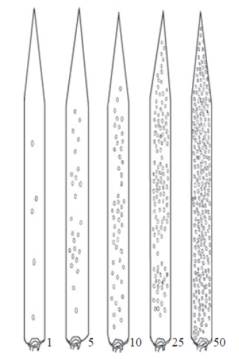 | 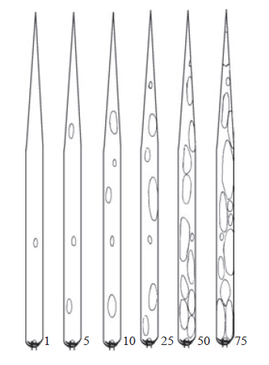

Erysiphe graminis on wheat and barley: percentage of leaf area affected.
OEPP/EPPO, Bulletin OEPP/EPPO Bulletin 42, 419–425

Yellow rust on wheat | Brown rust on barley
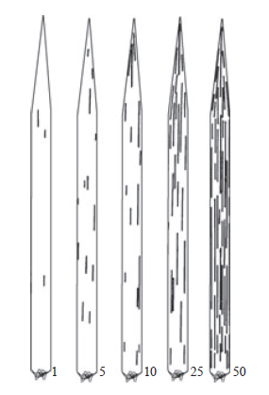 | 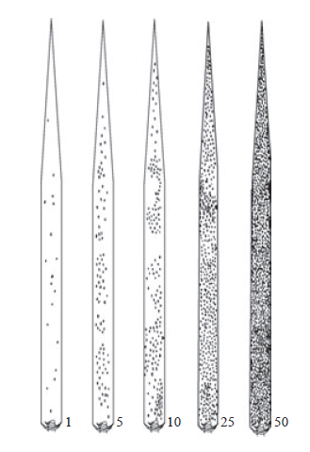

Puccinia striiformis on wheat: percentage of leaf area affected.
© Crown copyright 1976. Ministry of Agriculture, Fisheries and Food, (GB).Brown rust

Puccinia hordei on barley; Puccinia triticina on wheat: percentage of leaf area affected.
© Crown copyright 1976. Ministry of Agriculture, Fisheries and Food (GB).

Ear Blight of wheat (Fusarium spp.)

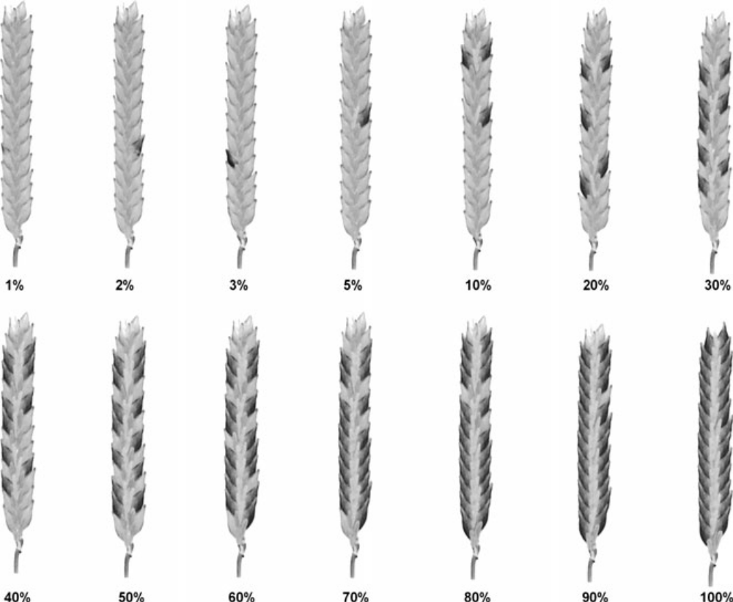

Septoria tritici

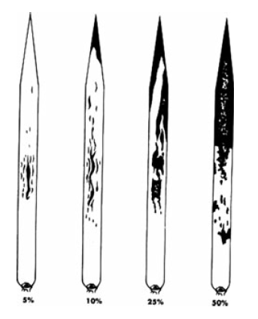
Septoria tritici on wheat; percentage of leaf area affected.
OEPP/EPPO, Bulletin OEPP/EPPO Bulletin 42, 419–425

Net blotch on barley | Rhynchosporium on barley
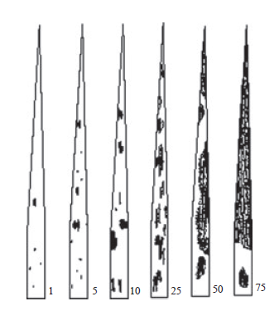 | 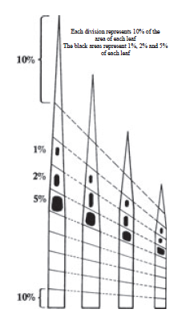

Pyrenophora teres on barley: percentage of leaf area affected.
OEPP/EPPO, Bulletin OEPP/EPPO Bulletin 42, 419–425

Rhynchosporium secalis on barley, percentage of leaf area affected.
© Crown copyright 1976. Ministry of Agriculture, Fisheries and Food (GB).

Eyespot of wheat (Pseudocercosporella herpotrichoides)
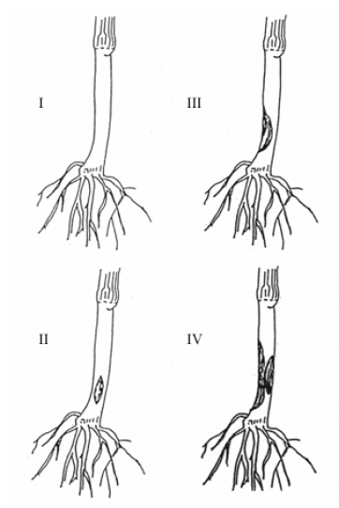
EPPO PP 1/28 (3)

Table 9 – disease severity categories for eyespot of wheat
Infection  category | Disease severity description
1 | Uninfected.
2 | Slight eyespot (one or more small lesions occupying less than half the circumference of the stem).
3 | Moderate eyespot (one or more lesions occupying at least half the circumference of the stem)
4 | Severe eyespot (stem completely girdled with lesions; tissue softened so that lodging would readily occur).

Notes of assessment

- Examine 20 tillers per plot.

- Assign each tiller to one of the infection categories above.

- Write the number of tillers in each category on the record sheet.

- An index will be calculated from the data using equation 1 as follows:

Equation 1
$$Disease index \left(DI\right)=\frac{\left(0×a\right) +\left(1×b\right)+\left(2×c\right)+\left(3×d\right)}{\left(a +b+c+d\right)}×\frac{100}{3}$$

Where a, b, c, and d are the number of tillers examined which fall into the categories 1, 2, 3 and 4 respectively.

For further details, see Scott, P R and Hollins, T W (1975). Effects of eyespot on the yield of winter wheat. Annals of Applied Biology 78, 269-279.

Appendix 2 – Assessment keys for oilseed rape diseases
Light leaf spot, Alternaria, downy mildew, Phoma and white leaf spot ON LEAVES AND PODS
- Examine all leaves and pods in 3 areas of each plot.
- Ignore all naturally senescent tissue.
- Include all necrosis and chlorosis attributable to disease.
- Estimate % infection using the descriptions below. Record the average % infection from the 3 areas. Interpolate values if necessary.
- Where stem are affected by of light leaf spot, record the % stem area with symptoms

Table 10 – assessment keys for oilseed rape diseases
% Infection | Leaves | Pods
0 | No infection observable | No infection observable
0.1 | Trace of infection | Trace of infection
1 | Diseased leaves with 1 small lesion;  plants with a few scattered lesions | Terminal raceme with a few scattered  lesions
5 | Leaves appear 1/10 infected; diseased  leaves with 2 lesions | Terminal raceme appears 1/10 infected.  Diseased pods with 1 or 2 lesions
10 | Leaves appear ¼ infected, diseased leaves with few large or many small lesions | Terminal raceme appears ¼ infected.  Diseased pods with 2 or more lesions
25 | Area appears ½ infected ½ green | Area appears ½ infected ½ green
50 | Area appears more infected than green | Area appears more infected than green
75 | Very little green tissue left | Very little green tissue left
100 | Leaves/pods dead – no green tissue left | Leaves/pods dead – no green tissue left

These descriptions are guides for specific levels; interpolate between these points as necessary e.g.15%, 27%, 60% etc.

Stem canker
Stem canker should be assessed from about the middle of June onwards, depending on season. External and internal symptoms should be assessed. Normally, 30 stems per plot from the central part of the middle row should be pulled up, and a length of about 30 cm cut off. Stem canker symptoms visible on the lower (10cm or so) external part of the stem should be scored according to the external scale column below. Using secateurs, each stem should then be cut transversely through the central part of the leaf scar region at the stem base, and the cross-sectional area of them stem affected by canker symptoms assessed according to the internal column.

Table 11 – assessment keys for stem canker
Rating | External symptoms | Internal symptoms
0 | No infection observable | No infection visible
1 | <25% girdling of the stem | Superficial – 1-5% surface area
2 | 26-50% girdling | 6-25% surface area
3 | 51-75% girdling | 26-50% surface area
4 | 76 -100% girdling | 51-75% surface area
5 | 100% girdling + stem weakness | 76-100% surface area
6 | 100% girdling + stem death | 100% area and stem death

A disease index for external and internal scores should be calculated using the following formula:

Equation 2
$$\frac{\left(0×a+1×b+2×c etc.\right)}{\left(a +b+c+etc.\right)} ×\frac{100}{6}$$

where a, b, c etc. are the number of plants in each disease category

A mean of the external and internal index must be submitted in an RL workbook, but records of external and internal indices should be retained.

Typical Verticillium stem stripe symptoms
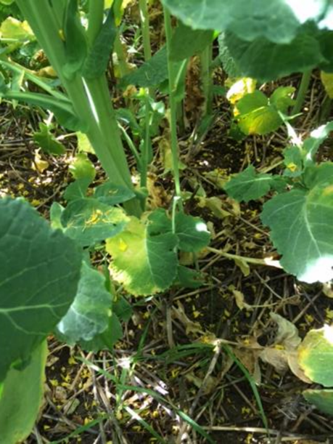 | 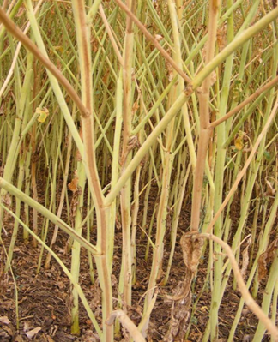
Figure 1. Early leaf symptoms of verticillium stripe on a susceptible variety in mid-May yellowing of half a leaf. | Figure 2. Characteristic striping along the length of the stems observed in early July.
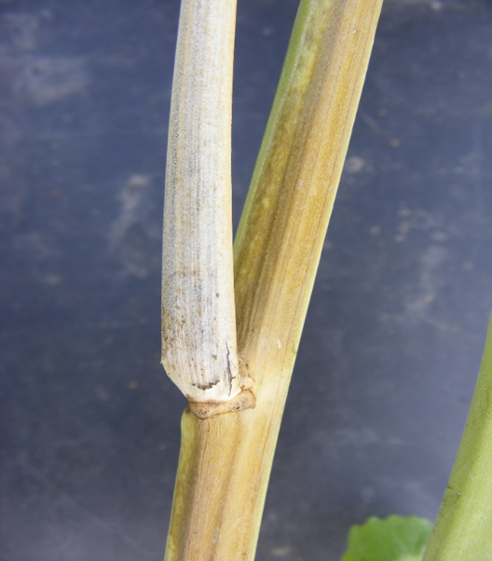 | 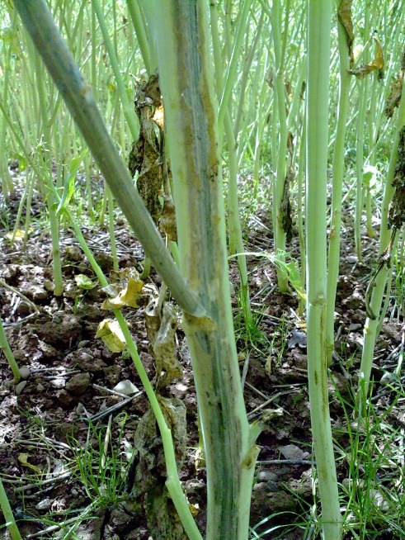
Figure 3. Close up of verticillium stripe showing an affected branch and the distinction between the brown stripe and green plant tissue. | Figure 4. Scraped stem reveals vascular staining not visible on the outside of the stem.

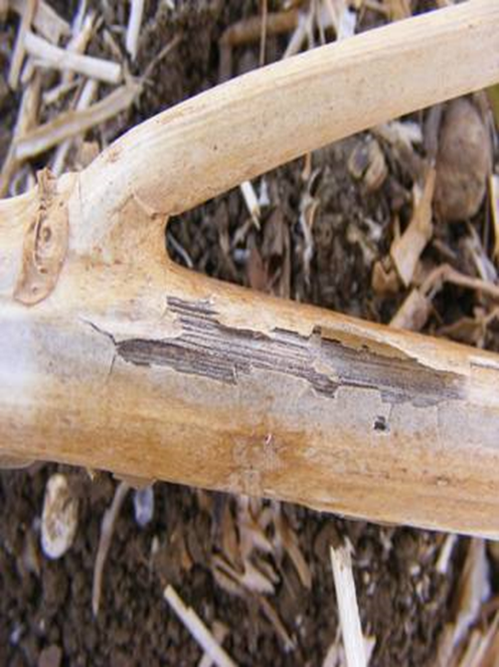
Figure 5. Microsclerotia, exposed due to the stem surface becoming dried out, paper-like and splitting, on winter oilseed rape in mid-July.

Other diseases

Club root
Any suspected club root in trials should be confirmed by sampling between 10 and 30 plants within the suspected area, and its presence notified to the RL disease lead.

Sclerotinia %
Should be assessed as the % of stems with complete girdling leading to 'whiteheads' within a plot.

Botrytis%
Should be assessed as the % of stems affected within a plot.

Verticillium (non verticillium trials) %
Should be recorded as the % of stems affected within a plot. If Verticillium stem stripe is observed, please inform the Disease Trials Coordinator at the earliest possible opportunity. You may be asked to do a more in-depth assessment following the separate verticillium stem stripe protocol which assesses verticillium index (for extra payment).

Appendix 3 Inoculated disease tests 2022-2027
Table 12 – Summary of inoculated disease tests (2022-2027) by crop type
Key: WW=winter wheat, AW=late-sown winter/spring wheat, SW=spring wheat, WB=winter barley, SB=spring barley, WO=winter oats, SO=spring oats, WR=winter oilseed rape. *Primary sites. Contractors bidding for trials marked* must be equipped to produce disease inoculum as directed by the protocol and provide this inoculum to non-primary sites.
Crop | Trial no. | Trial type | Preferred location | Time of sowing | Notes | Reps
AW | 855 | *Yellow rust | East (south of a line Bristol to the Wash) | Late autumn | Includes supply of inoculum | 2
AW | 856 | *Brown rust | South of England | Late autumn | Includes supply of inoculum | 2
SB | 935 | Net blotch | In high net bloch risk area - justify in tender | Spring | Includes supply of inoculum | 2
SB | 937 | Net blotch | In high net bloch risk area - justify in tender | Spring | N/a | 2
SB | 936 | *Brown rust | South of England | Spring | Includes supply of inoculum | 2
SB | 940 | Brown rust | North of England | Spring | N/a | 2
SB | 941 | Rhynchosporoium | West/SW/Wales or W. Scotland - Irrigation must be available | Spring | N/a | 2
SO | 938 | *Crown rust | East of England | Spring | Includes supply of inoculum | 2
SO | 939 | Crown rust | Southwest of England | Spring | N/a | 2
WO | 901 | *Crown Rust | East of England | Autumn | Includes supply of inoculum | 2
WO | 902 | Crown Rust | Southwest of England | Autumn | Includes supply of inoculum | 2
WB | 880 | *Brown rust | South of England | Autumn | N/a | 2
WB | 881 | Brown rust | North of England | Autumn | Includes supply of inoculum | 2
WB | 882 | *Net blotch | In high net bloch risk area - justify in tender | Autumn | Includes supply of inoculum | 2
WB | 883 | Net Blotch | In high net bloch risk area - justify in tender | Autumn | N/a | 2
WB | 884 | Rhynchosporoium | West/SW/ of England, Wales or West Scotland | Autumn | N/a | 2
WR | 886 | *Phoma & light leaf spot 1 | East of England and at least 30 miles from Phoma & LLS site 2 | Autumn | Includes supply of inoculum | 4
WR | 887 | Phoma & light leaf spot 2 | West of England and at least 30 miles from Phoma & LLS site 1 | Autumn | N/a | 4
WR | 888 | Verticillium |  | Autumn | Natural infection or inoculation | 4
WR | 889 | Verticillium |  | Autumn | Natural infection or inoculation | 4
WW | 823 | *Eyespot site 1 | At least 30 miles from WW eyespot site 2 | Autumn | Includes supply of inoculum | 4
WW | 824 | Eyespot site 2 | At least 30 miles from WW eyespot site 1 | Autumn | N/a | 4
WW | 825 | *Yellow rust trial 1 | East of England and at least 30 miles away from WW YR site 2 | Autumn | Includes supply of inoculum | 2
WW | 826 | Yellow rust trial 2 | East of England and at least 30 miles away from WW YR site 1 | Autumn | N/a | 2
WW | 827 | *Brown rust | South of the Wash | Autumn | Includes supply of inoculum | 2
WW | 829 | *Fusarium site 1 trial 1 | East/south of England | Autumn | Includes supply of inoculum. | 3
WW | 830 | *Fusarium site 1 trial 2 | East/south of England | Autumn | Includes supply of inoculum. | 3
WW | 831 | *Fusarium site 1 trial 3 | East/south of England | Autumn | Includes supply of inoculum. | 3
WW | 832 | Fusarium site 2 trial 1 | East/south of England | Autumn | N/a | 3
WW | 833 | Fusarium site 2 trial 2 | East/south of England | Autumn | N/a | 3
WW | 834 | Fusarium site 2 trial 3 | East/south of England | Autumn | N/a | 3

Appendix 4 – Payments for abandoned or rejected trials
Table 13 – Summary of payments for abandoned or rejected trials
Reason for failure or loss of data | Payment proportion of trial | Payment proportion of replicate
Trial not drilled due to factors outside of the trial operator's control (e.g. weather). | 25% | N/a
Trial not drilled due to controllable factors (e.g. missed opportunity to drill) | 0% | N/a
Trial failed to establish due to factors outside of the trial operator's control (e.g. waterlogging where there is no history of any problem). | 50% | 50%
Trial failed to establish due to controllable factors (e.g. bird damage) | 0% (see note 1) | 0% (see note 1)
Trial abandoned mid-season due to excessive OSR volunteers in OSR trial if in an unsuitable rotational position (<5 yrs since OSR crop). | 25% (see note 2) | 25% (see note 2)
Trial abandoned mid-season due to Excessive OSR volunteers in OSR trial if in a suitable rotational position (>5 yrs since OSR crop). | 50% | 50%
Trial abandoned mid-season due to excessive cereal volunteers | 25% | 25%
Trial abandoned mid-season due to factors outside of the trial operator's control (e.g. drought or waterlogging where there is no history of any problem). | 50% | 50%
Trial abandoned mid-season due to controllable factors (e.g. excessive weeds or pest damage). | 25% (see note 3) | 25% (see note 3)
Trial completed but no results obtained due to disease not establishing, caused by factors outside of the trial operator's control (e.g. drought or high temperatures) | 25% | 25%
Trial completed but no results obtained due to disease not establishing, caused by controllable factors (e.g. protocol not followed). | 50% (see note 4) | 50% (see note 4)
Trial completed but data unavailable or loss of accuracy to data, caused by incorrect treatment mid-season (trial operator or host farm error). | 50% | 50%
Trial completed but data unavailable or loss of accuracy to data, caused by trial drilled with errors or by not following the plan correctly. | TBC (see note 5) | TBC (see note 5)
Trial completed but data omitted due to factors outside of the trial operator's control (e.g. take all or drought) | 100% | 100%
Trial completed but data omitted due to factors under the control of the operator | 50% | 50%

Note 1 - Controllable factors: This assumes that it has been possible to take corrective action, but it has not been done. If the operator has been unable to take action due to (e.g.) weather the payment will be 50%.

Note 2 - Unless there has been written prior agreement to place trial on a site that has grown OSR <5 years ago.

Note 3 - This includes trials sown in a location that increases the risk of damage (e.g. too close to a wood or other potential sources of animal activity such as a badger sett).

Note 4 - If irrigation or misting was specified for this trial in the protocol and this was not applied

Note 5 - A decision on payment for this problem can only be determined on a case-by-case basis, depending on the amount of data or accuracy lost.

Contact us
AHDB, Siskin Parkway East, Middlemarch Business Park, Coventry CV3 4PE

Email: info@ahdb.org.uk

